COMP124 Assignment1

# Requirements

Implement an assembly program that does the following. Firstly, it should ask the user to enter marks for six modules These marks are to be entered into an array.

After all marks have been entered, the program should count up the number of passes and fails, and then print them out. A pass is considered to be a mark of 40% or above

The marks are assumed to be integers in the range 0-100. If a mark is outside the range, it should not be accepted, and the request should be repeated.

The marks must be stored in an array, the counting of passes and fails should not be performed until this stage is complete.

# Approach

I will first write a program with the basic requirements in python then use this as a template for moving the code across to assembly. When coding this it is more efficient to miss out details such as verification as this is often easier to understand the basic function of.

## Python code

stack = [] # declare the vairables at the start

passes = 6

fails = 0

for i in range(1,7): #for each of the 6 values

stack.append(input('Enter the mark for module '+str(i)+':')) # add the mark to the array

for i in stack: # for each mark in the array increment fails by one if <40

if i<40:

fails+=1

passes += - fails # passes = 6-fails

print 'Number of passes = ' +str(passes) # print number of passes

print 'Number of fails = ' +str(fails) # print number of fails

# Testing

To test the program I tested the boundaries and commented on whether it behaved as expected and if this was an error how in which it would be.

|  |  |  |  |  |  |  |  |  |  |
| --- | --- | --- | --- | --- | --- | --- | --- | --- | --- |
| Module 1 | Module 2 | Module 3 | Module 4 | Module 5 | Module 6 | Passes | Fails | Expected +comments | Screenshot |
| 0 | 0 | 0 | 0 | 0 | 0 | 0 | 6 | As expected, no issues | 1 |
| 40 | 40 | 40 | 40 | 30 | 50 | 5 | 1 | As expected, No issues | 2 |
| -1 | - | - | - | - | - | - | - | Asked for Repeated entry, Until new Value was put in, as expected | 3 |
| 50 | 50 | 50 | 50 | 50 | 50 | 6 | 0 | As Expected, No issues | 4 |
| 100 | 100 | 100 | 100 | 100 | 100 | 6 | 0 | As Expected, No issues | 5 |
| 101 | - | - | - | - | - | - | - | Asked for Repeated entry, Until new Value was put in, as expected | 6 |

## Screenshots

1.

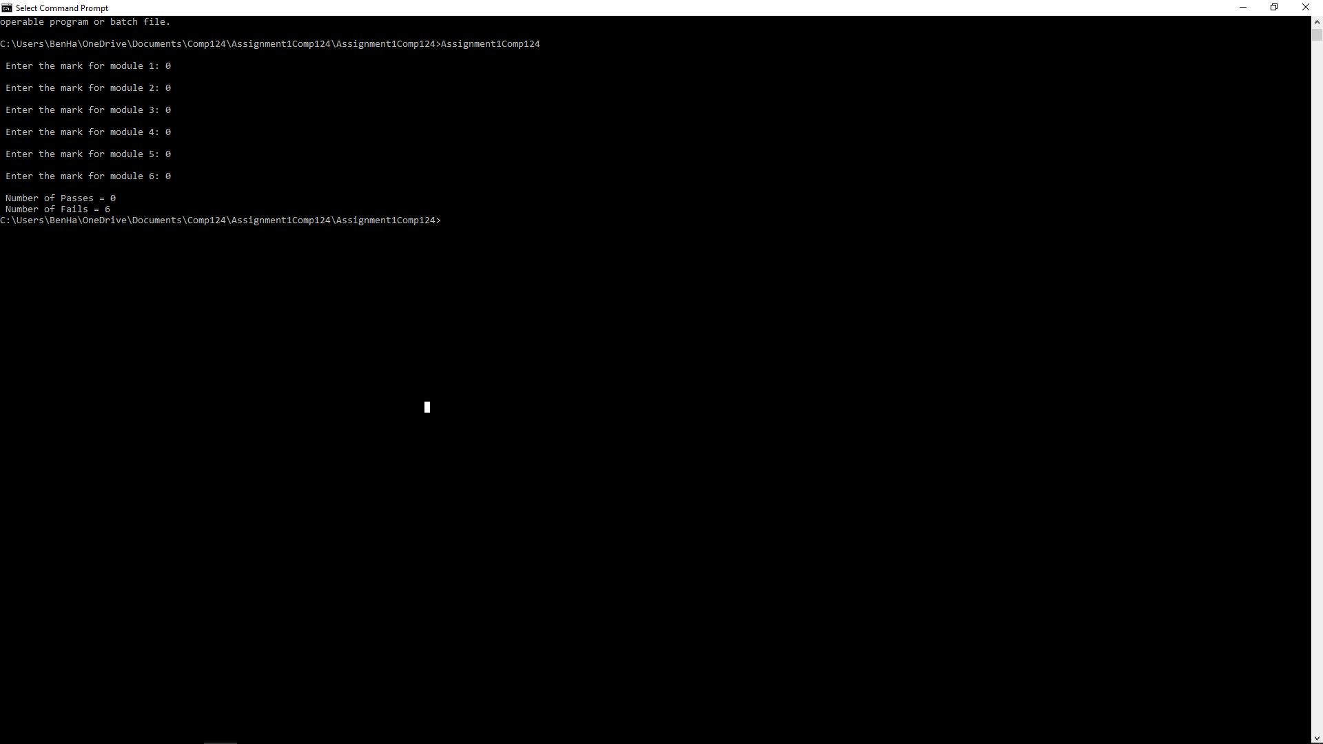

2.

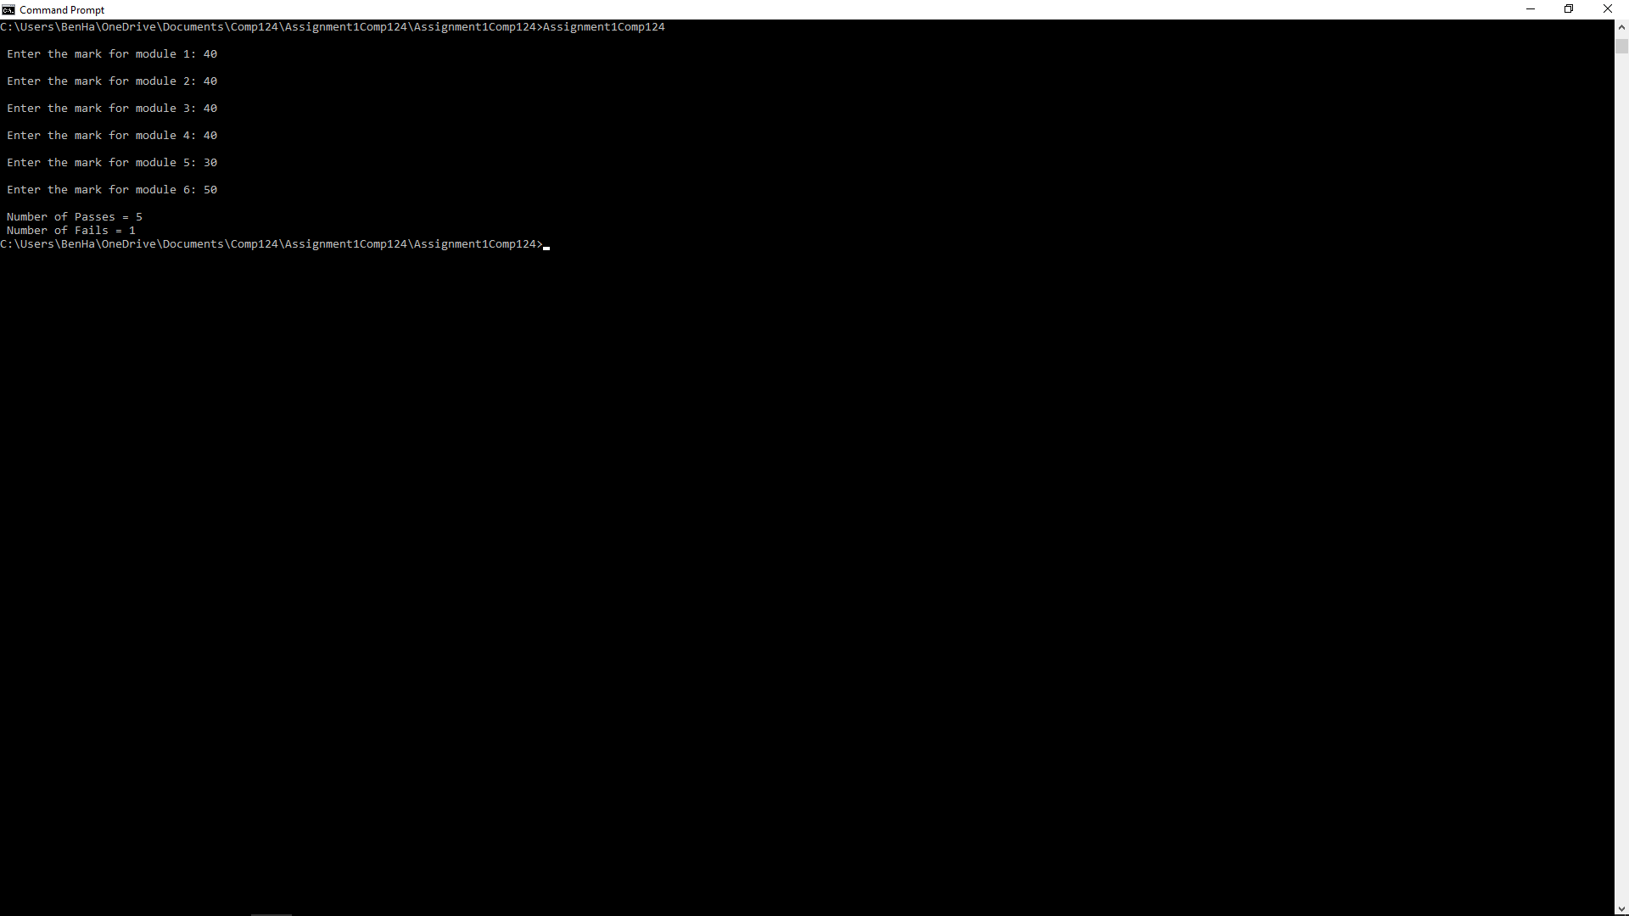

3.

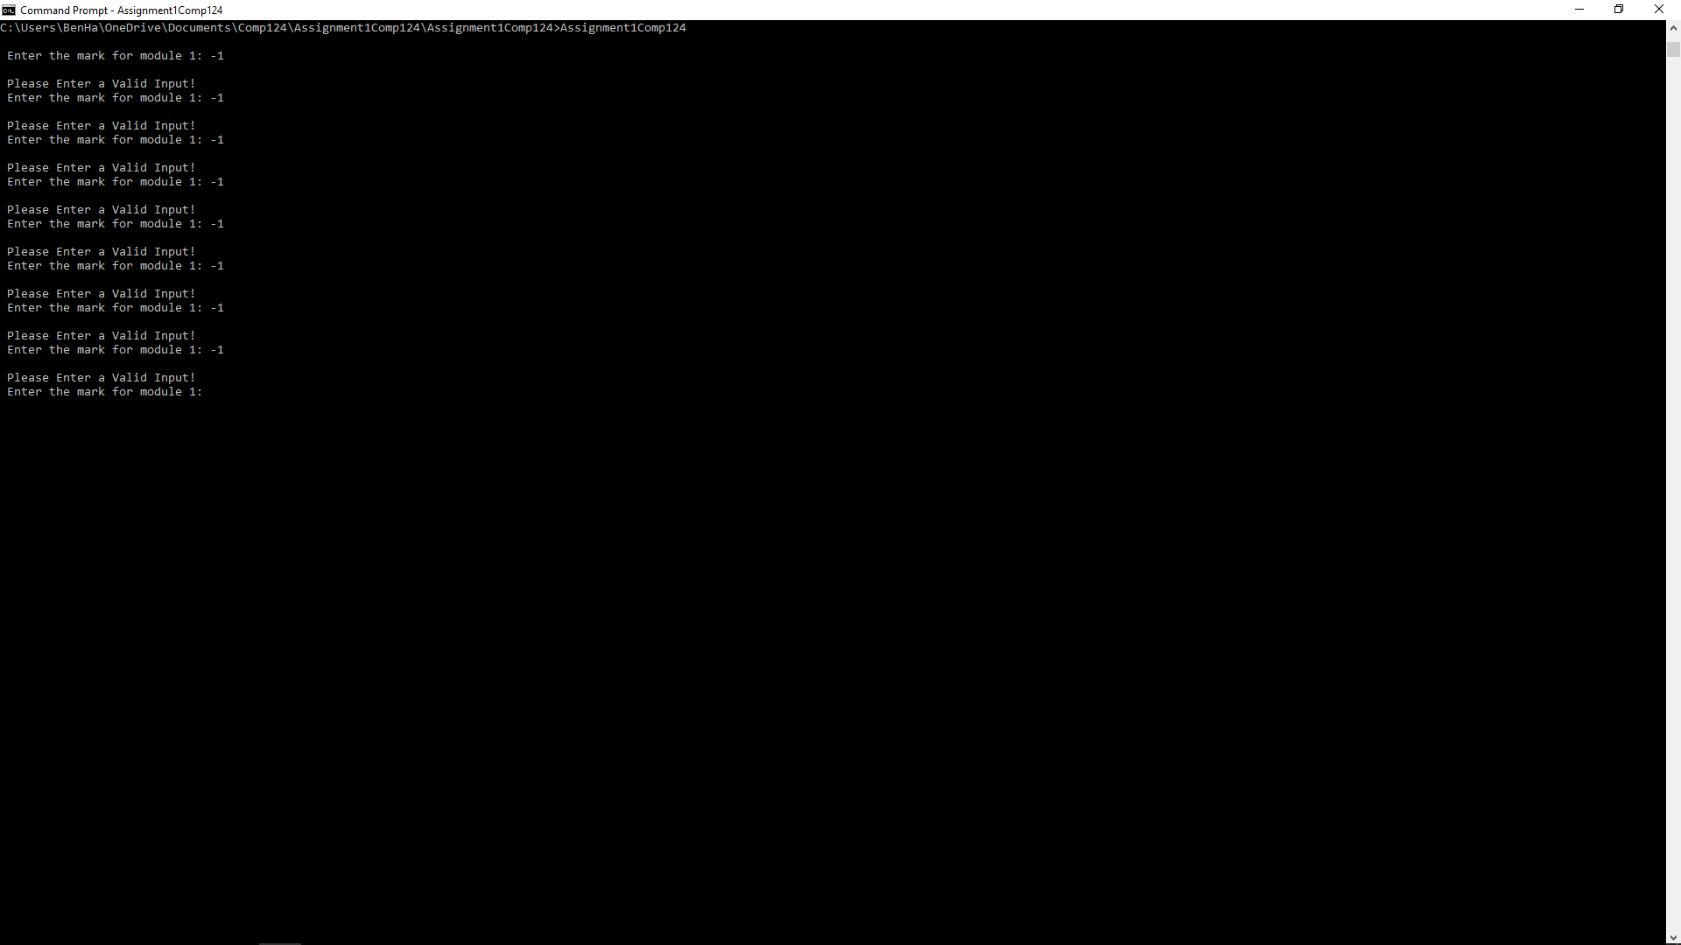

4.

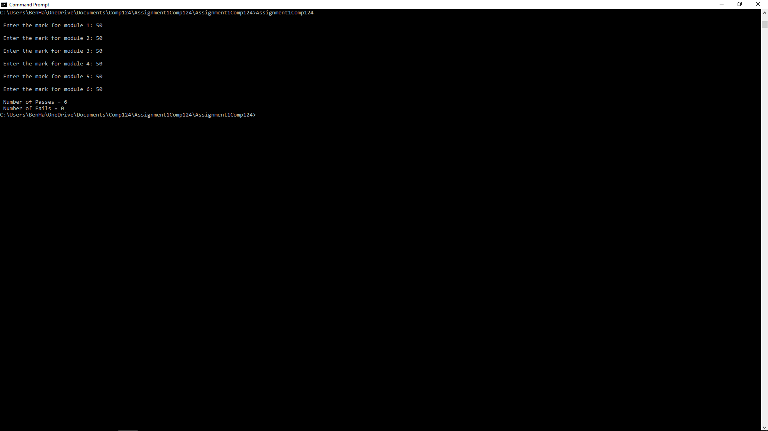

5.

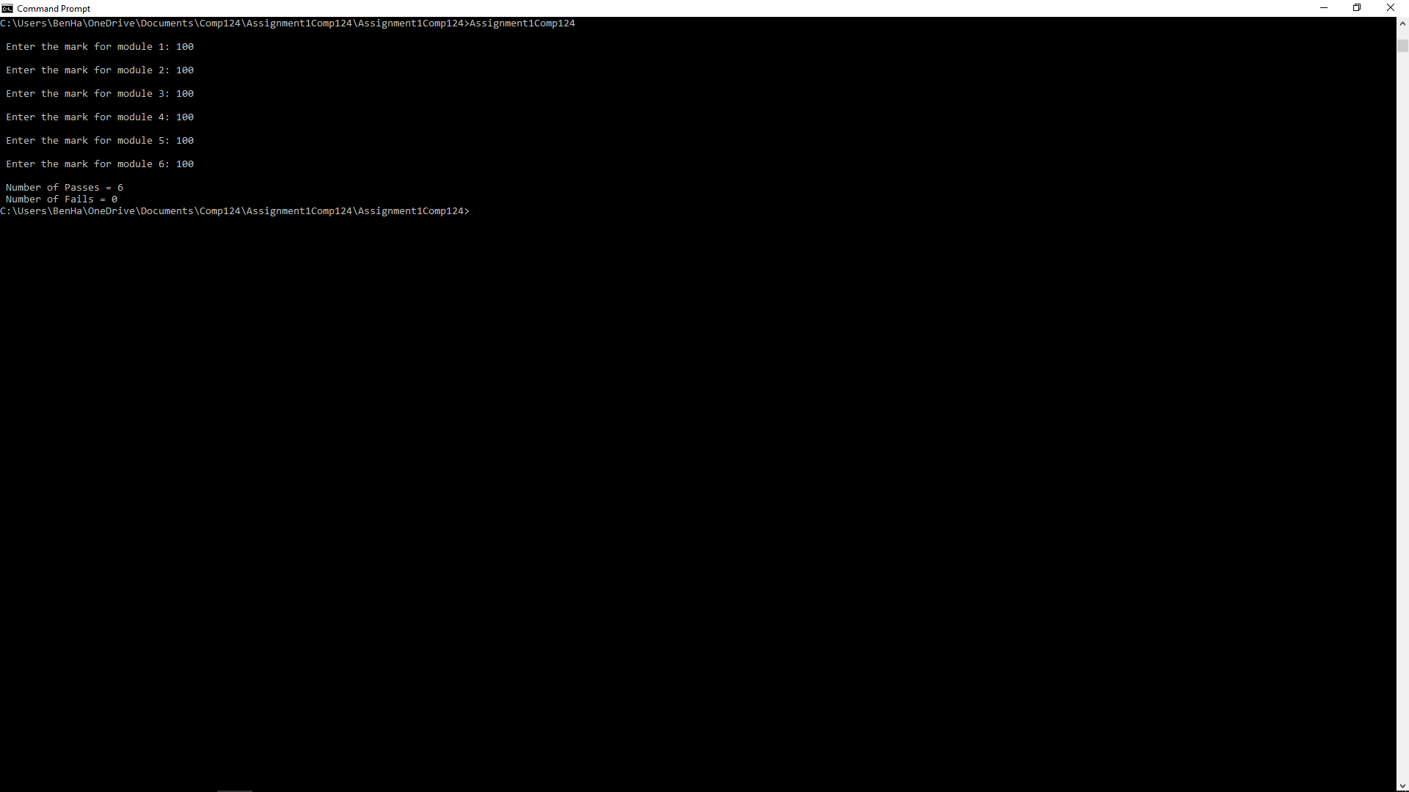

6.

